


Version: 5.1.2
Published date: August 2026
Copyright © 2026 by ESW. All rights reserved. Information contained herein is subject to change without notice.

Embedded Checkout (EC) INTEGRATION GUIDE

SFCC - ESW Cartridge
+
Table of Contents
1.Embedded Checkout 3
2.Order flow 3
3.Enable Embedded Checkout on retailer’s website 4
3.1. Import metadata and services 5
3.2. BM Configurations 6
4.Display on storefront 7
5.Code Customizations 9

Embedded Checkout

Embedded Checkout allows shoppers to complete their purchases directly within the retailer’s storefront using an iFrame provided by ESW. This feature enhances the shopping experience by keeping the entire checkout process on the retailer’s site, thereby increasing shopper trust and confidence.

Order flow
When embedded checkout is enabled then order will be placed in SFCC only if it is confirmed from ESW (by calling order confirmation webhook from ESW to SFCC). However in order flow without EC the order is placed in SFCC when shopper click on Checkout button on the storefront.
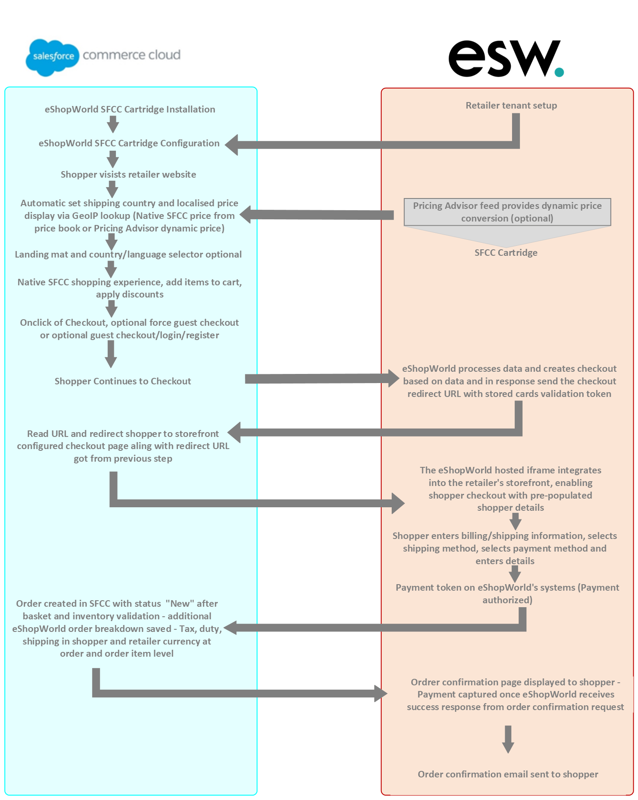

Enable Embedded Checkout on retailer’s website
To enable the Embedded Checkout feature on the storefront, the retailer must first ensure that the feature is activated on the ESW tenant side. In addition, few configurations need to be applied within the SFCC Business Manager. The following section provides details on how to update these configurations.

Import metadata and services
Import Metadata:
Retailer needs to Import site preference attributes (systemobjects_spark.xml) from link_eshopworld\sitesdata\meta.
After importing meta data, retailer should be able to see following in the SFCC BM
Custom Preferences:
“ESW SPARK Integration Configuration” group in Site Preferences along with following attributes:
- ESW SPARK Script Path: This is the path of the LTI script, this preference will also act as feature toggle so that if valid path is added then EC will work otherwise shopper will be redirected to ESW
- ESW SPARK Cookie Name: The cookie will be used to attempt to retrieve the URL from the cookie if it is not set in the eswiframeurl parameter (For example, in case of browser refresh).
- SPARK Dynamic Pricing Enabled: Set this to Yes to enable Spark pricing conversion, or No to disable it. Please note that this is not
- ESW Spark iFrame Checkout Enabled: Set this preference to Yes to enable the iFrame Checkout or No to disable it.

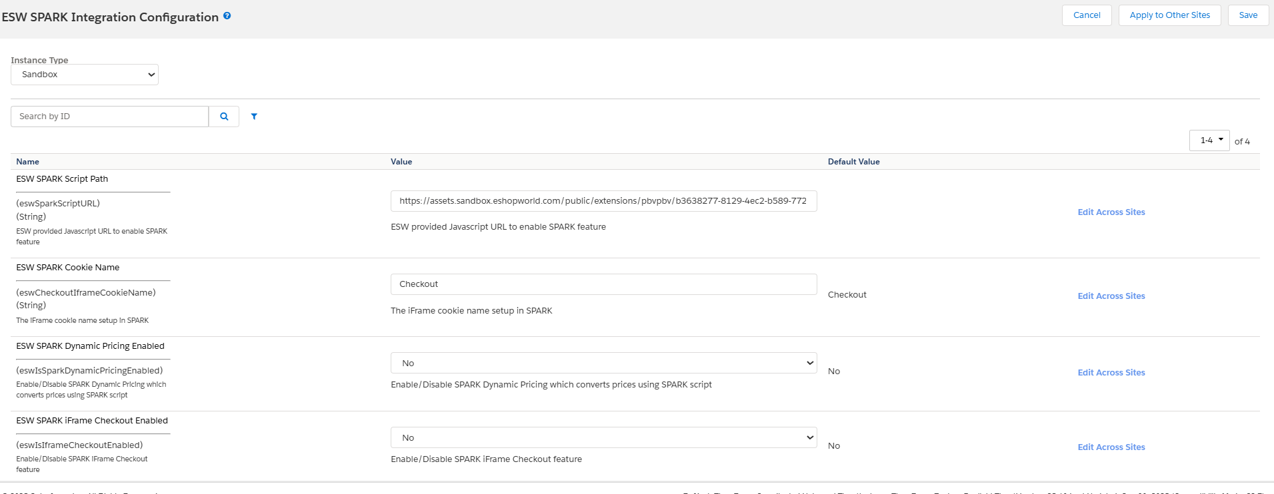

The Following preference is added to the group “ESW General Configuration”
- ESW SFCC OCAPI Client ID: This is OCAPI/SCAPI client id of the instance.
The following preference is added to the Group “ESW Headless Integration Configuration”
- ESW Headless Site URL: This is Site URL of retailer’s Headless domain which will be concatenated with LTI script path to redirect the shopper to embedded checkout
Order level attribute:
- ESW Basket UUID: This new attribute will be added to the Order however it’s not assigned to any group so will not be visible on Order screen.
  - Attribute ID: eswBasketUuid
  - Type: String
  - Purpose: In a preorder, the retailerCartId will be set to basketUUID_{timeStamp} to prevent any duplication in ESW. This same attribute will be used to cancel the order through an order cancellation call from ESW.
Import Services:
Services can be import from (services.xml) from link_eshopworld\Metadata
After importing services, the following service will be available:
- ESWOcapiService : This service is used to interact with the OCAPI Shop API for operations such as basket management and order creation.
https://realm.dx.commercecloud.salesforce.com/s/{siteId}/dw/shop/v{ocapi_version}/

BM Configurations
Following configs needs to be done in the BM to enable the feature:
- Goto “Merchant Tools > Site Preferences > Custom Site Preference Groups > ESW SPARK Integration Configuration” and add following values:
  - ESW SPARK Script Path: This is the path of the LTI script.
  - ESW SPARK Fallback URL: This is the fallback URL so that in case of iframe failure, shopper will be redirected to this path. Should be same as LTI configurations
  - ESW SFCC OCAPI Client ID: This is OCAPI client id of the instance.
- If you are using headless storefront, Ensure to add value in the following “Merchant Tools>Site Preferences>Custom Site Preference Groups> ESW Headless Integration
  - ESW Headless Site URL: This is Site URL of retailer’s Headless domain which will be concatenated with LTI script path to redirect the shopper to embedded checkout

- Goto “Merchant Tools > Site Preferences > Custom Site Preference Groups > ESW Checkout Configuration”
  - Update “ESW Metadadata Items” by adding following value:
    - OrderConfirmationUri_TestOnly|EShopWorld-EswEmbeddedCheckoutNotify
    - OrderConfirmationBase64EncodedAuth_TestOnly|1 parameters
- Set cartridge path to:
  - PWA: “int_eshopworld_spark:int_eshopworld_pwa:int_eshopworld_core:app_storefront_base:modules”
  - SFRA: “int_eshopworld_spark:int_eshopworld_sfra:int_eshopworld_core:app_storefront_base:modules”
  - SG: “int_eshopworld_saprk:int_eshopworld_controllers:int_eshopworld_core:SG_controllers:SG_core:modules”
  - Headless: “int_eshopworld_spark:int_eshopworld_headless:int_eshopworld_core:app_storefront_base:modules”
- Make sure that “int_eshopworld_spark” is available
- Now BM is ready to use the Embedded Checkout feature.

Display on storefront
On storefront, if EC is enabled, then upon click on the Checkout button the shopper will be redirected to the URL. For each architects following are the URLs
- SFRA: https://storefront.url/EShopWorld-EswEmbeddedCheckout?eswiframeurl=checkoutUrlFromPreOrder
- SG: https://storefront.url/EShopWorldSG-EswEmbeddedCheckout?eswiframeurl=checkoutUrlFromPreOrder
- PWA: https://storefront.url/esw-checkout?eswiframeurl=checkoutUrlFromPreOrder#
- HeadlessSFRA: https://storefront.url/EShopWorld-EswEmbeddedCheckout?eswiframeurl=checkoutUrlFromPreOrder
- HeadlessSG: https://storefront.url/EShopWorldSG-EswEmbeddedCheckout?eswiframeurl=checkoutUrlFromPreOrder

Please note that the query param “eswiframeurl” is static and can not be change. The preorder Url will removed from the URL through LTI script. The final display of the iFrame is shown: 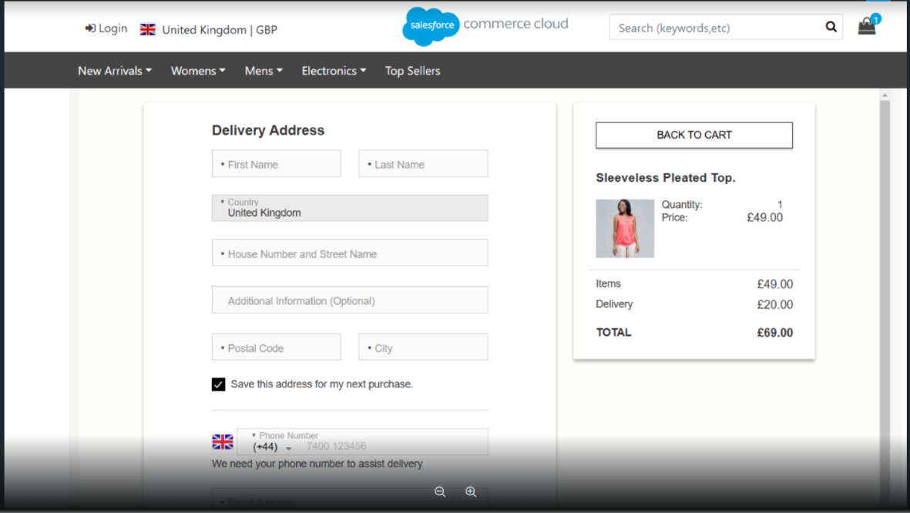
After completing the the payment the order confirmation will looks like:
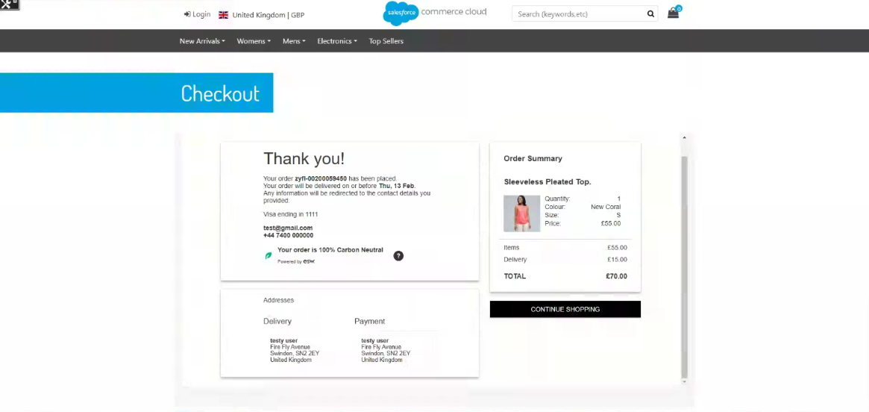
Note: If, for any reason, the iframe fails to load on the shopper’s browser, the page will be redirected to the native ESW checkout as a fallback.

Code Customizations
To implement embedded checkout, a few customizations are required in the code base. If you need to copy the code, please do so from the provided cartridge instead of the Word file. The details are as follows:

SFRA:
- No customization is required for SFRA.
PWA:
- Open “link_eshopworld\esw-pwa-app\overrides\app\routes.jsx”
  - Import the “EswEmbeddedCheckout” component
import EswEmbeddedCheckout from './pages/esw-embedded-checkout'
  - Add route with following configuration
{
path: '/esw-checkout',
component: EswEmbeddedCheckout,
exact: true
}
- For detailed PWA integration please follow the docs “eShopWorld_Cartridge_Pwa_Integration.docx”

SG:
- Open “/link_eshopworld/cartridges/int_eshopworld_controllers/cartridge/controllers/EShopWorldSG.js”
  - Require following 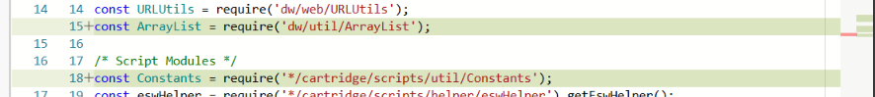
  - Update “function preOrderRequest()”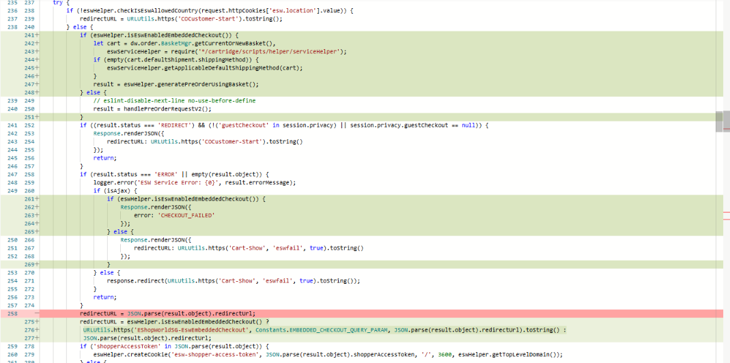
  - Add following:
/**
* Function to handle Embeded Checkout order confirmation request in V2
*/
function eswEmbeddedCheckoutNotify() {
let eswCoreApiHelper = require('*/cartridge/scripts/helper/eswCoreApiHelper'),
eswCoreService = require('*/cartridge/scripts/services/EswCoreService').getEswServices(),
eswOcapiServiceHelper = require('*/cartridge/scripts/services/EswOcapiService').getEswOcapiServices,
embCheckoutHelper = require('*/cartridge/scripts/helper/eckoutHelper').eswEmbCheckoutHelper;
let Transaction = require('dw/system/Transaction'),
logger = require('dw/system/Logger'),
ProductMgr = require('dw/catalog/ProductMgr'),
responseJSON = {};
let preorderServiceObj = eswCoreService.getSFCCOcapi();
let currentBasketData = null;

if (eswHelper.getBasicAuthEnabled() && !request.httpHeaders.authorization.equals('Basic ' + eswHelper.encodeBasicAuth())) {
response.setStatus(401);
logger.error('ESW Order Confirmation Error: Basic Authentication Token did not match');
} else {
try {
let obj = JSON.parse(request.httpParameterMap.requestBodyAsString);

eswHelper.eswInfoLogger('Esw Order Confirmation Request', JSON.stringify(obj));

let ocHelper = require('*/cartridge/scripts/helper/orderConfirmationHelper').getEswOcHelper();

let inventoryValidationPlis = { productLineItems: new ArrayList([]) };
let dwSid = eswHelper.getDwsid(obj);
let basketID = eswHelper.getRetailerCartId(obj.retailerCartId);
let customerEndpoint = Constants.CUSTOMER_AUTH + eswHelper.getOcapiClientID();
let customerAuth = preorderServiceObj.call({ requestBody: { type: 'session' }, endpoint: customerEndpoint, dwsid: dwSid });
let authKey = customerAuth.ok && !empty(customerAuth.object) ? customerAuth.object.getResponseHeader('authorization') : null;
let shopperCurrency = ('checkoutTotal' in obj) ? obj.checkoutTotal.shopper.currency : obj.shopperCurrencyPaymentAmount.substring(0, 3);
ocHelper.setOverridePriceBooks(obj.deliveryCountryIso, shopperCurrency);

let ocapiBasketResponse = eswOcapiServiceHelper.ocapiBasketService().call({
basketId: basketID,
httpMethod: 'GET',
authToken: authKey
});

if (ocapiBasketResponse.isOk() && !empty(ocapiBasketResponse.getObject())) {
currentBasketData = JSON.parse(ocapiBasketResponse.object.text);

if (eswHelper.getEnableInventoryCheck()) {
for (let i = 0; i < currentBasketData.product_items.length; i++) {
inventoryValidationPlis.productLineItems.add({
product: ProductMgr.getProduct(currentBasketData.product_items[i].product_id),
quantityValue: currentBasketData.product_items[i].quantity
});
}
if (!ocHelper.validateEswOrderInventory(inventoryValidationPlis)) {
throw new Error('Inventory validation failed');
}
}
}

let isValidBasket = eswCoreApiHelper.compareBasketAndOcProducts(currentBasketData, obj);
if (!isValidBasket) {
throw new Error('Basket data from OCAPI and ESW Checkout are not equal');
}

let ocapiOrderResponse = eswOcapiServiceHelper.ocapiOrderService().call({
httpMethod: 'POST',
authToken: authKey,
basketId: basketID,
countryCode: obj.deliveryCountryIso
});

if (ocapiOrderResponse.isOk() && !empty(ocapiOrderResponse.getObject())) {
let orderData = JSON.parse(ocapiOrderResponse.object.text);
Transaction.wrap(function () {
embCheckoutHelper.processUpdateOrderAttributes(orderData.order_no, obj, null);
});

responseJSON = {
OrderNumber: orderData.order_no,
EShopWorldOrderNumber: obj.eShopWorldOrderNumber,
ResponseCode: '200',
ResponseText: 'Success'
};
} else {
throw new Error('Error while generating order from the basket');
}
} catch (e) {
logger.error('ESW Service Error: {0}', e.message);
if (e.name === 'SystemError') {
response.setStatus(429);
responseJSON.ResponseCode = '429';
responseJSON.ResponseText = 'Transient Error: Too many requests';
} else {
response.setStatus(400);
responseJSON.ResponseCode = '400';
responseJSON.ResponseText = 'Error: Internal error';
}
}

eswHelper.eswInfoLogger('Esw Order Confirmation Response', JSON.stringify(responseJSON));
}

Response.renderJSON(responseJSON);
}
  - Add following:
/**
* Function to be called to render ESW Embeded Checkout page
*/
function eswEmbeddedCheckout() {
app.getView({
eswCheckoutUrl: request.httpQueryString.eswiframeurl
}).render('checkout/eswEmbeddedCheckout');
}
  - Add routes:
/** Renders the Embeded checkout
* @see module:controllers/EShopWorldSG~eswEmbeddedCheckout */
exports.EswEmbeddedCheckout = guard.ensure(['get'], eswEmbeddedCheckout);

/** Handles the order confirmation request
* @see module:controllers/EShopWorldSG~EsWEmbeddedCheckoutNotify */
exports.EsWEmbeddedCheckoutNotify = guard.ensure(['post'], eswEmbeddedCheckoutNotify);
- Add template “/link_eshopworld/cartridges/int_eshopworld_controllers/cartridge/templates/default/checkout/eswEmbeddedCheckout.isml”

